**EXPERIMENT 03**

**AIM: TO DEVELOP A NATIVE APPLICATION THAT ACCESS GPS LOCATION**

**OUTPUT:**

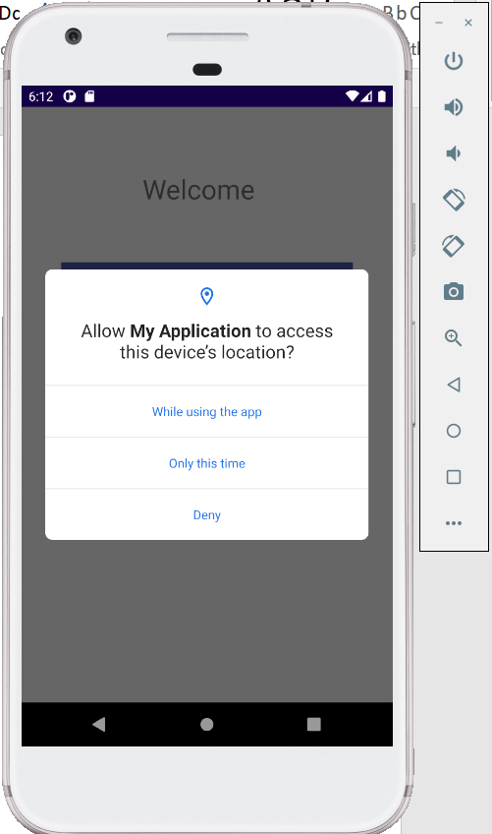

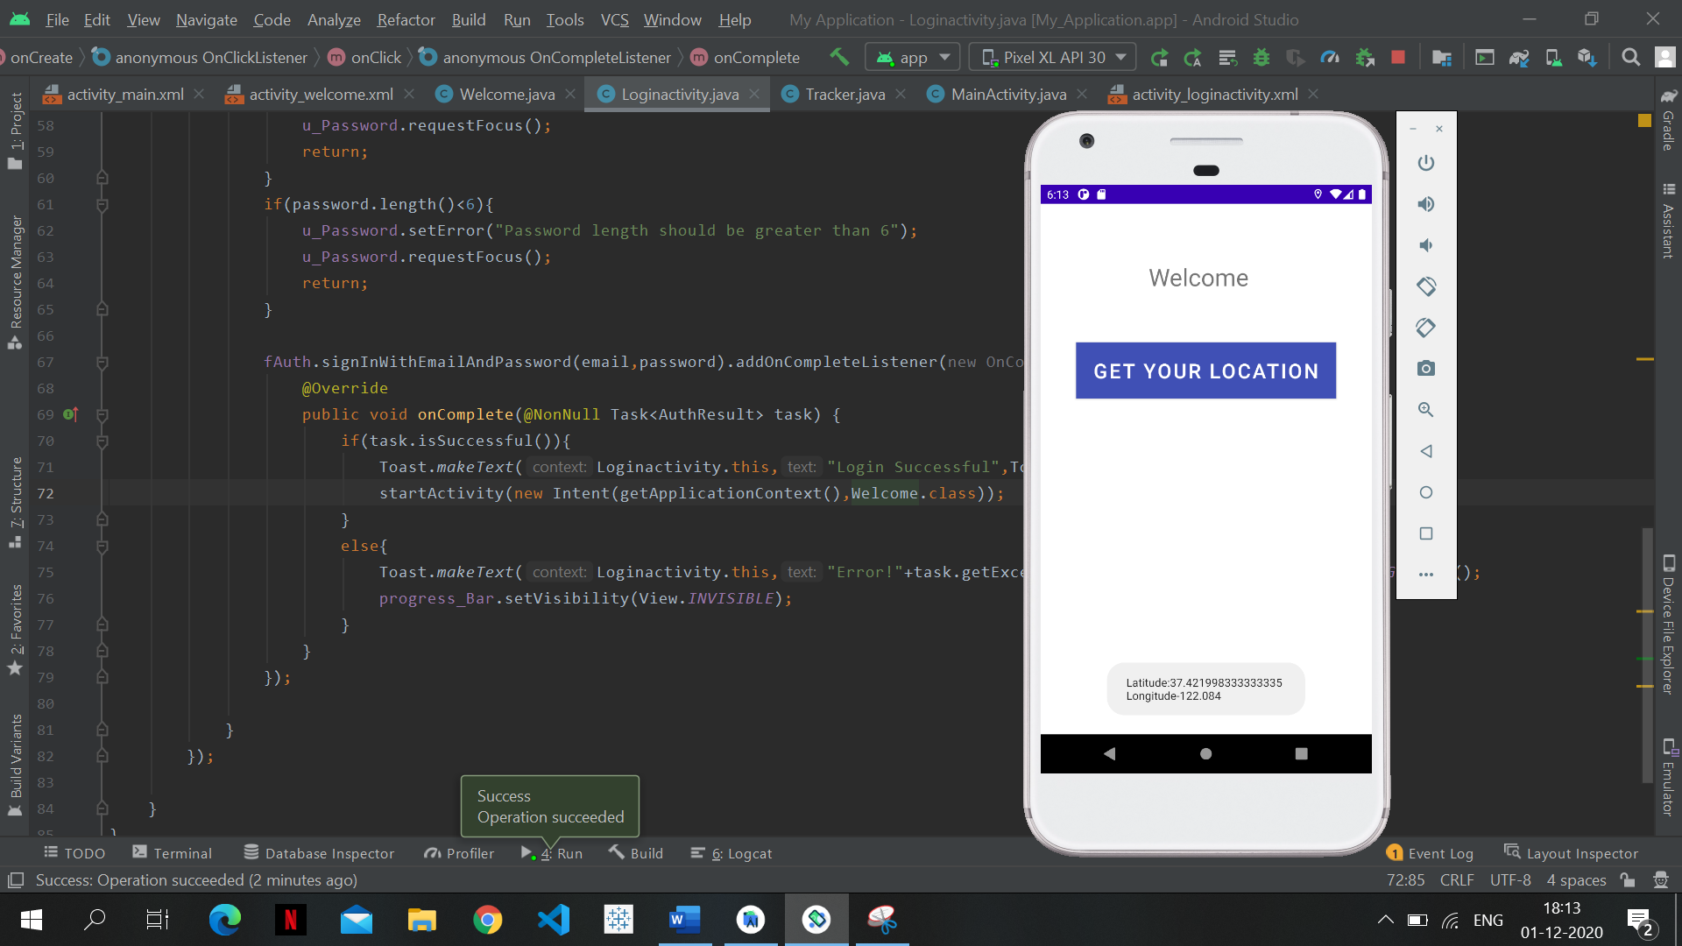

**CHANGING THE EMMULATOR LOCATIONS AND RETRYING ACCESSING THE GPS INFORMATION:**

